Test Case: tc002_SPX_Dev5_Crear_Requisicion_Spot_Con_FAD_Tipo_Cobro_CC
Step 1 - Enter username and password and click to button Enter : Credentials Entered
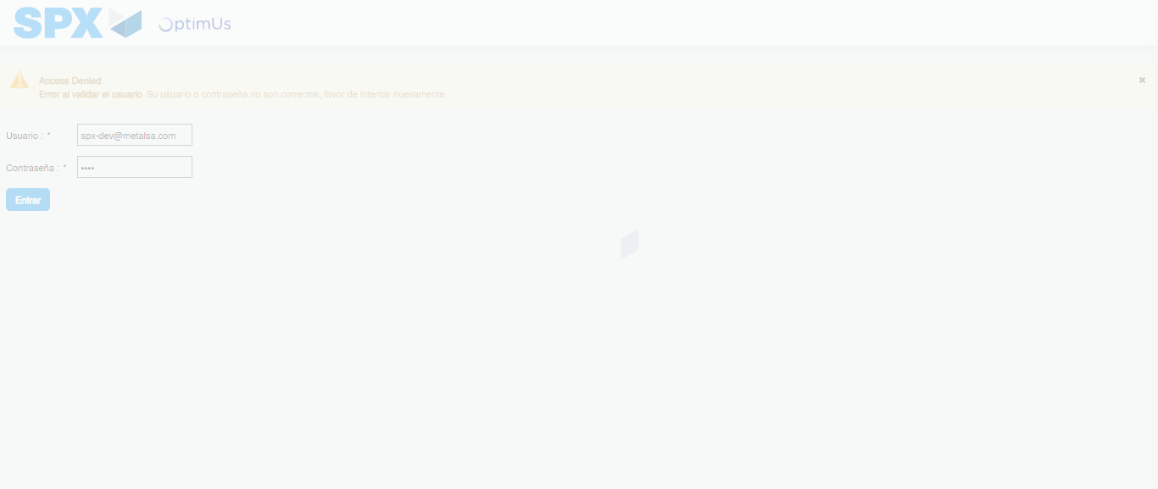Image file-name: QC_Testing-tc002_SPX_Dev5_Crear_Requisicion_Spot_Con_FAD_Tipo_Cobro_CC-1785960474661

Step 2 - Select to UEN and Access to Spot Buy Requisitions : UEN Correctly selected and Correct access
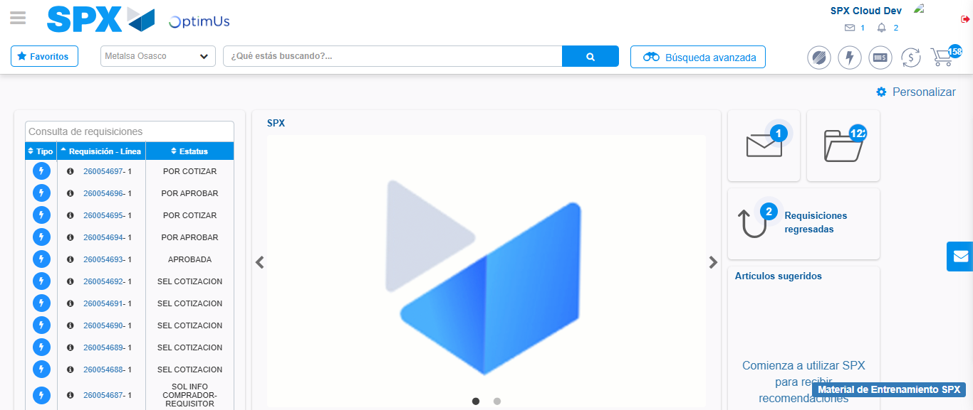Image file-name: QC_Testing-tc002_SPX_Dev5_Crear_Requisicion_Spot_Con_FAD_Tipo_Cobro_CC-1785960499749

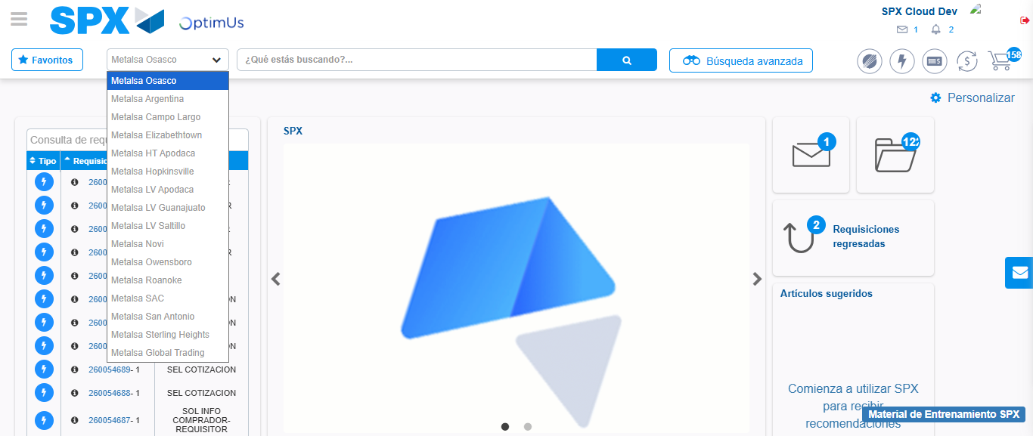Image file-name: QC_Testing-tc002_SPX_Dev5_Crear_Requisicion_Spot_Con_FAD_Tipo_Cobro_CC-1785960502277

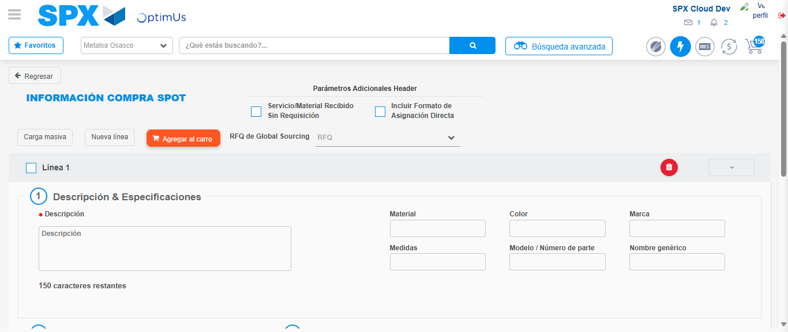Image file-name: QC_Testing-tc002_SPX_Dev5_Crear_Requisicion_Spot_Con_FAD_Tipo_Cobro_CC-1785960509597

Step 3 - Add FAD to Requisition: FAD Successfully Added
Image file-name: QC_Testing-tc002_SPX_Dev5_Crear_Requisicion_Spot_Con_FAD_Tipo_Cobro_CC-1785960509830

Image file-name: QC_Testing-tc002_SPX_Dev5_Crear_Requisicion_Spot_Con_FAD_Tipo_Cobro_CC-1785960509983

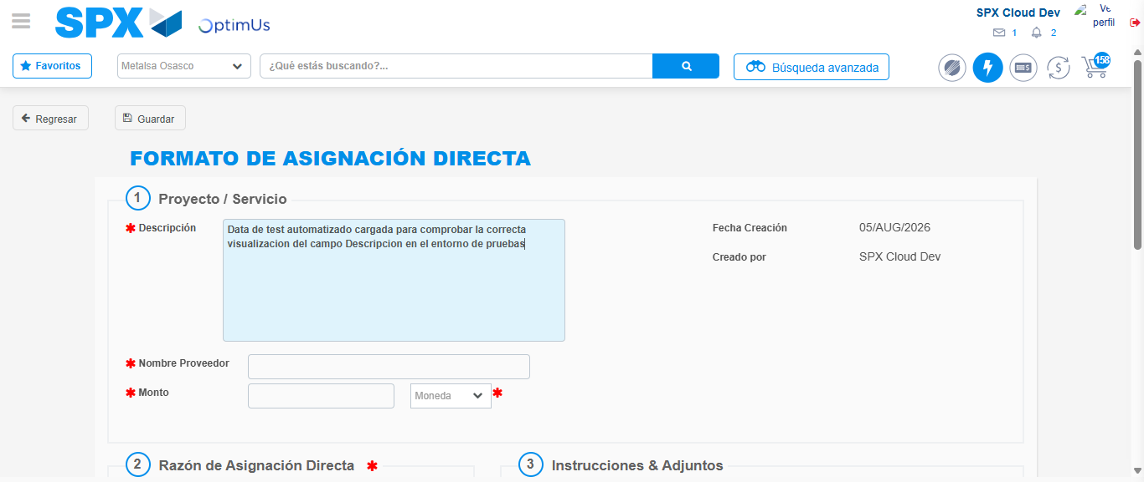Image file-name: QC_Testing-tc002_SPX_Dev5_Crear_Requisicion_Spot_Con_FAD_Tipo_Cobro_CC-1785960512644

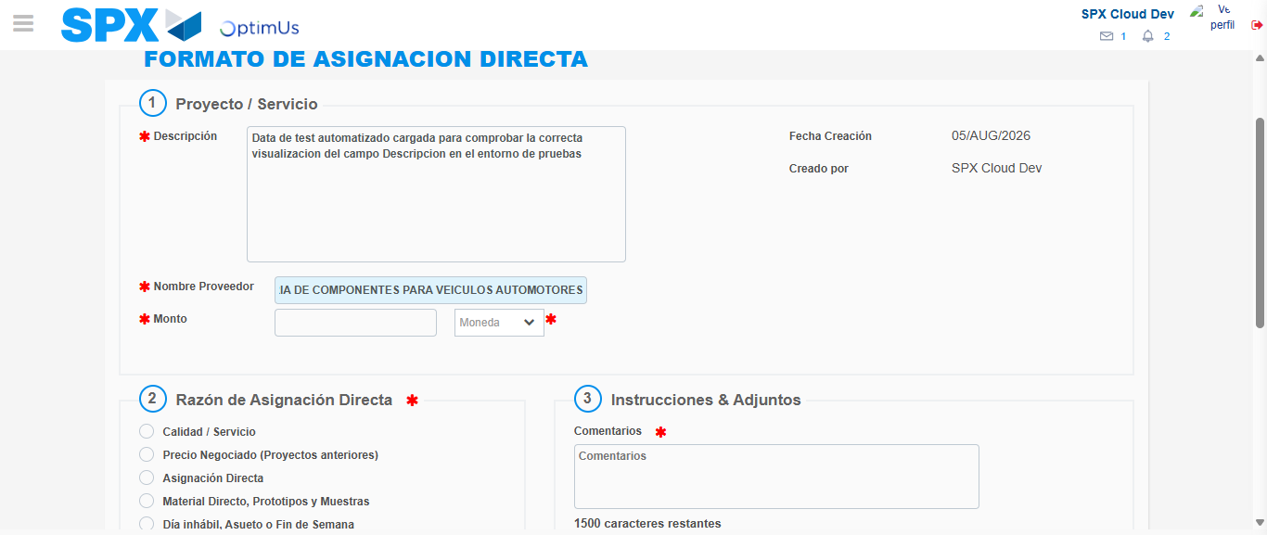Image file-name: QC_Testing-tc002_SPX_Dev5_Crear_Requisicion_Spot_Con_FAD_Tipo_Cobro_CC-1785960521783

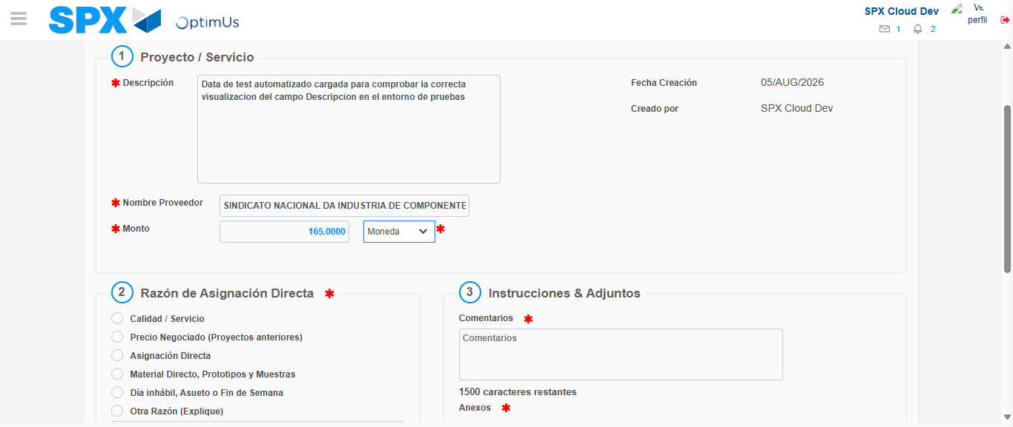Image file-name: QC_Testing-tc002_SPX_Dev5_Crear_Requisicion_Spot_Con_FAD_Tipo_Cobro_CC-1785960522129

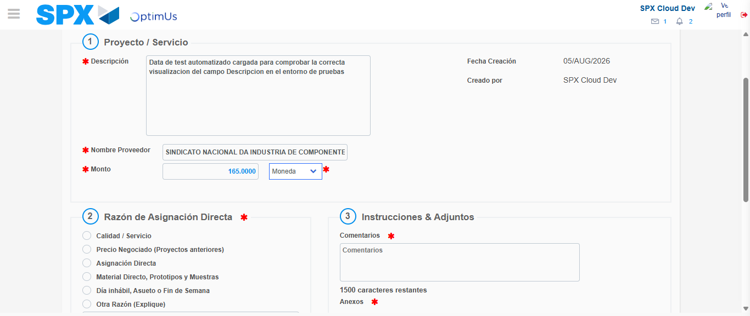Image file-name: QC_Testing-tc002_SPX_Dev5_Crear_Requisicion_Spot_Con_FAD_Tipo_Cobro_CC-1785960522315

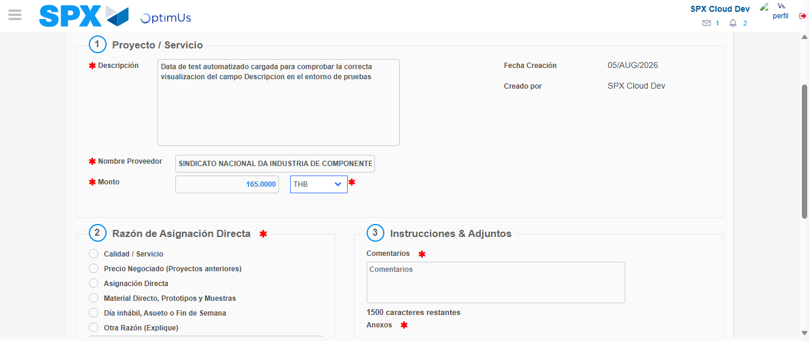Image file-name: QC_Testing-tc002_SPX_Dev5_Crear_Requisicion_Spot_Con_FAD_Tipo_Cobro_CC-1785960522628

Image file-name: QC_Testing-tc002_SPX_Dev5_Crear_Requisicion_Spot_Con_FAD_Tipo_Cobro_CC-1785960522842

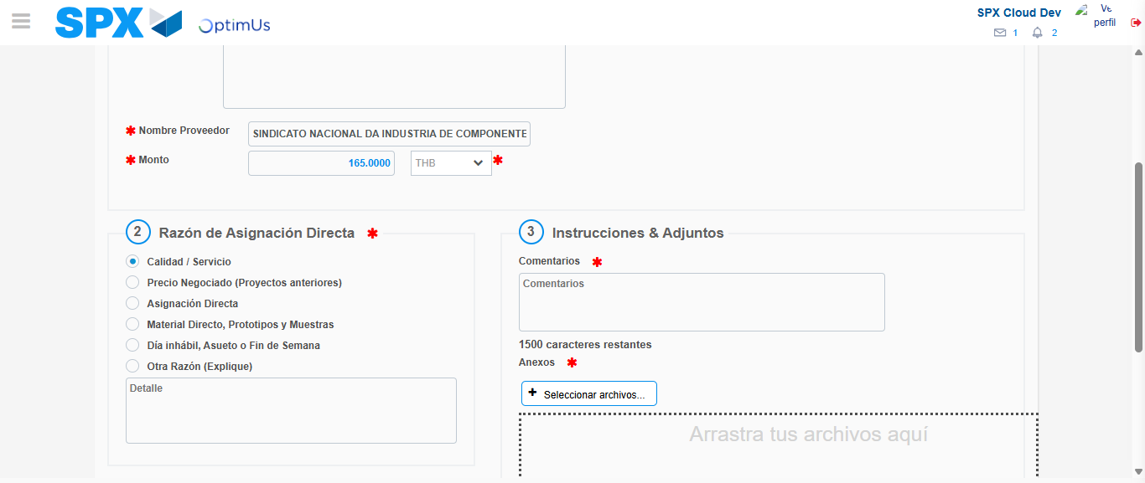Image file-name: QC_Testing-tc002_SPX_Dev5_Crear_Requisicion_Spot_Con_FAD_Tipo_Cobro_CC-1785960523682

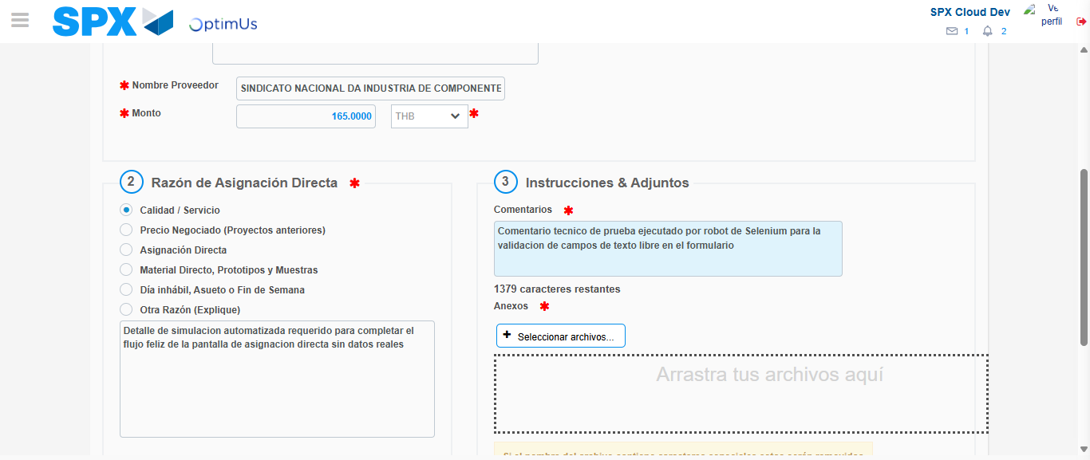Image file-name: QC_Testing-tc002_SPX_Dev5_Crear_Requisicion_Spot_Con_FAD_Tipo_Cobro_CC-1785960534688

Image file-name: QC_Testing-tc002_SPX_Dev5_Crear_Requisicion_Spot_Con_FAD_Tipo_Cobro_CC-1785960535415

Step 4 - Data Capture Spot Buy Requisition: Data captured correctly
Image file-name: QC_Testing-tc002_SPX_Dev5_Crear_Requisicion_Spot_Con_FAD_Tipo_Cobro_CC-1785960509830

Image file-name: QC_Testing-tc002_SPX_Dev5_Crear_Requisicion_Spot_Con_FAD_Tipo_Cobro_CC-1785960509983

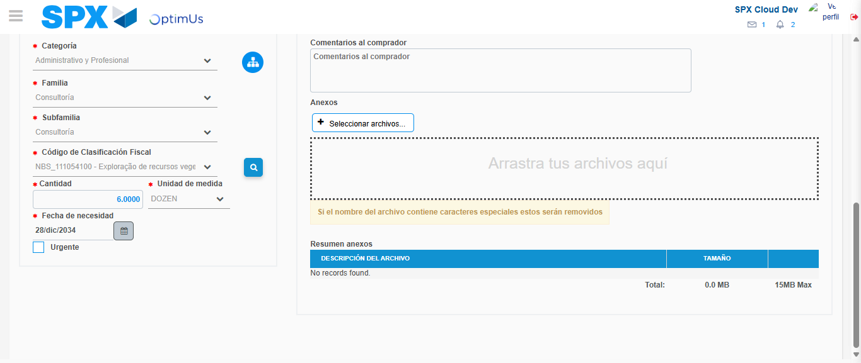Image file-name: QC_Testing-tc002_SPX_Dev5_Crear_Requisicion_Spot_Con_FAD_Tipo_Cobro_CC-1785960552623

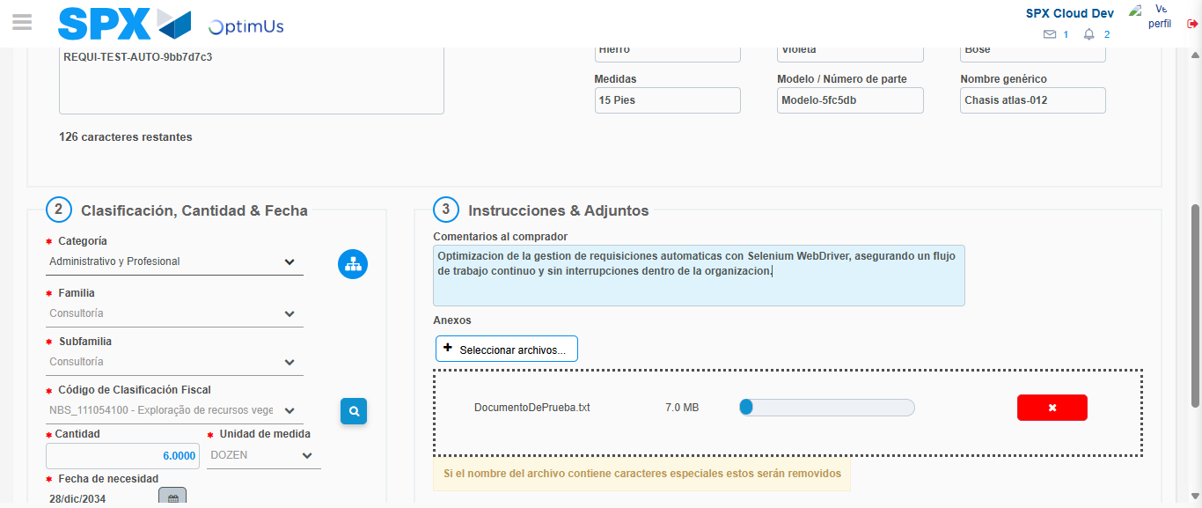Image file-name: QC_Testing-tc002_SPX_Dev5_Crear_Requisicion_Spot_Con_FAD_Tipo_Cobro_CC-1785960553400

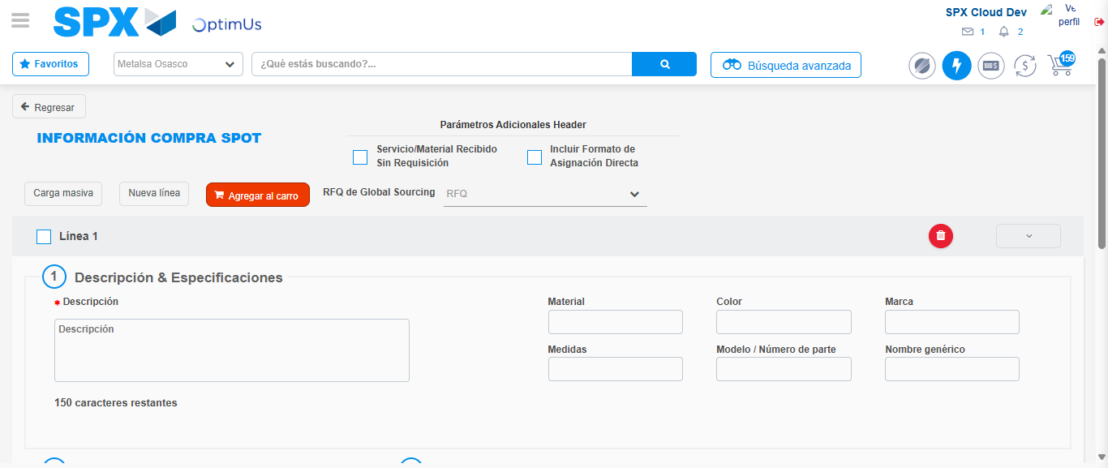Image file-name: QC_Testing-tc002_SPX_Dev5_Crear_Requisicion_Spot_Con_FAD_Tipo_Cobro_CC-1785960563353

Step 8 - Return to Main Page SPX : Return to Main Page SPX
Image file-name: QC_Testing-tc002_SPX_Dev5_Crear_Requisicion_Spot_Con_FAD_Tipo_Cobro_CC-1785960499749

Image file-name: QC_Testing-tc002_SPX_Dev5_Crear_Requisicion_Spot_Con_FAD_Tipo_Cobro_CC-1785960502277

Image file-name: QC_Testing-tc002_SPX_Dev5_Crear_Requisicion_Spot_Con_FAD_Tipo_Cobro_CC-1785960509597

Image file-name: QC_Testing-tc002_SPX_Dev5_Crear_Requisicion_Spot_Con_FAD_Tipo_Cobro_CC-1785960565680

Image file-name: QC_Testing-tc002_SPX_Dev5_Crear_Requisicion_Spot_Con_FAD_Tipo_Cobro_CC-1785960565867

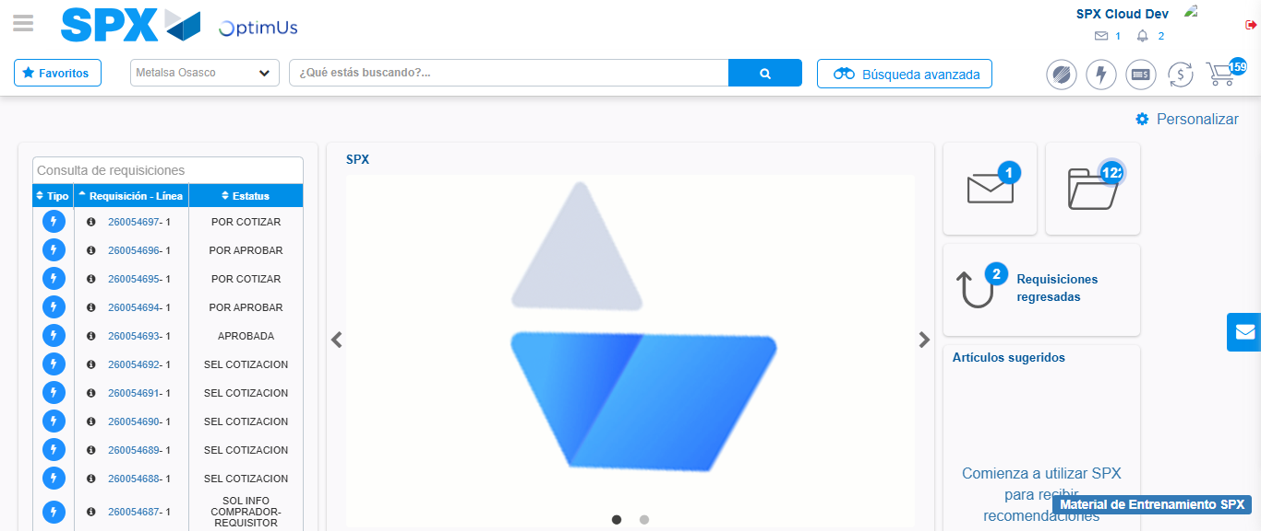Image file-name: QC_Testing-tc002_SPX_Dev5_Crear_Requisicion_Spot_Con_FAD_Tipo_Cobro_CC-1785960587029

Step 9 - Log Out : Log Out SPX
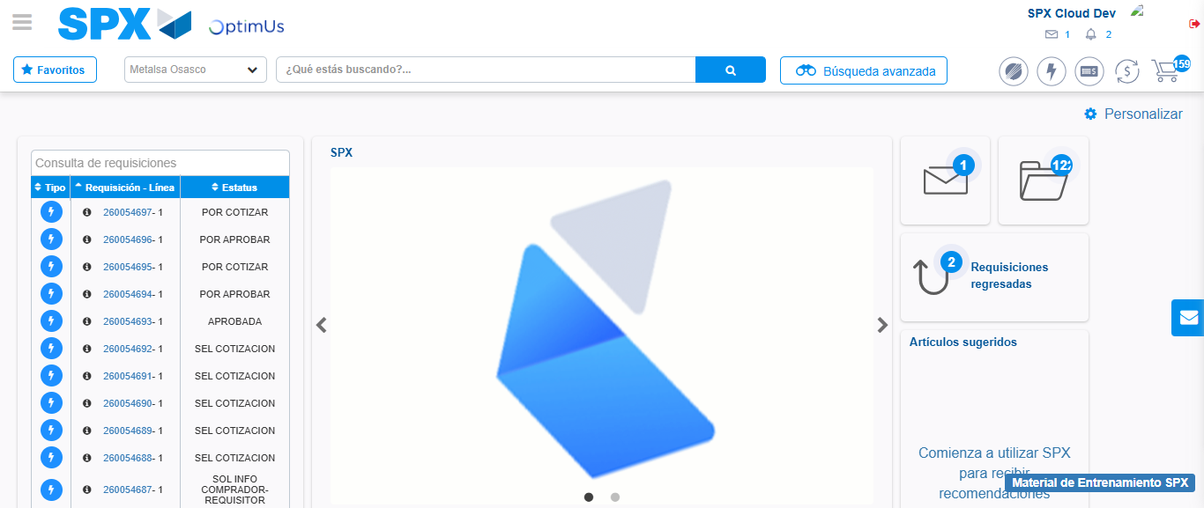Image file-name: QC_Testing-tc002_SPX_Dev5_Crear_Requisicion_Spot_Con_FAD_Tipo_Cobro_CC-1785960587322

